# Practice Exercise 4

(Total Marks: 100%, 3%)

**Part#1**

Creating Media Queries

Instructions: In this exercise, you will use your text editor to add tablet and desktop media queries to a style sheet. You will create style rules for a tablet viewport and a desktop viewport. You then add a style rule for an image element to style the pictures in two columns for a tablet viewport and three columns for a desktop viewport. The completed webpage is shown in Figure 6–53 for a tablet viewport and Figure 6–54 for a desktop viewport. You will also use professional web development practices to indent, space, comment, and validate your code.

 

Perform the following tasks:

1. Open apply06.html in your browser to view the webpage.

2. Open apply06.html in your text editor, review the page, and modify the comment at the top of the page to include your name and today’s date.

3. Open the applystyles06.css file from the apply\css folder. Modify the comment at the top of the style sheet to include your name and today’s date.

4. In the applystyles06.css file, add a media query to target a tablet viewport. Use min-width: 481px and include the following comment, Styles for tablet layout.

5. Create a new style rule for the img element to set the width to 45% within the tablet media query.

6. In the applystyles06.css file, add a media query to target a desktop viewport. Use min-width: 769px and include the following comment, Styles for desktop layout.

7. Create a new style rule for the img element to set the img element to set the img width to width to width 30% within the desktop media query.

8. Save all of your changes and open the apply06.html in Google Chrome.

9. Use the developer tools in Google Chrome to view each viewport’s dimensions and determine a better viewport size for the desktop viewport.

10. Modify the desktop media query with the new value in the applystyles06.css file.

11. Validate your HTML document using the W3C validator found at validator.w3.org and fix any errors that are identified.

12. Validate your CSS file using the W3C validator found at http://jigsaw.w3.org/css-validator/ and fix any errors that are identified.

13. Submit the files in a format specified by your instructor.

**Part#2**

Modifying Media Queries

Instructions: Work with the analyze06.html file in the analyze folder and the analyzestyles06.css file in the analyze\css folder from the Data Files for Students. The analyze06.html webpage is a draft template, but must be corrected and improved for responsive design before presenting it to the client. Use Figure 6–56 and Figure 6–57 as a guide to correct these files.

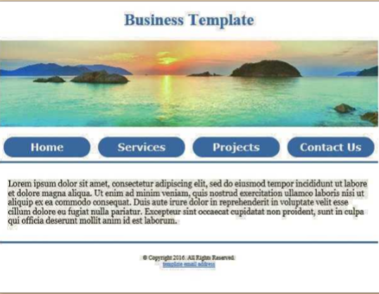

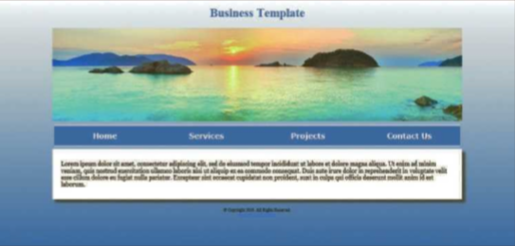

1. Correct

a. Open the analyze06.html file in your editor from the Data Files for Students and then modify the comment at the top of the page to include your name and today’s date.

b. Open the analyzestyles06.css file in your editor from the Data Files for Students and then modify and correct the comment at the top of the document to include your name and today’s date.

c. View analyze06.html in your browser and resize the page to display mobile, tablet, and View analyze06.html in your browser and resize the page to display mobile, tablet, and desktop viewports. The navigation links for the tablet viewport extend beyond their boundary at the current breakpoint.

d. Open analyze06.html in Google Chrome and use the developer tools to determine the dimensions for a tablet viewport.

e. In the analyzestyles06.css file, modify the tablet media query with a suitable breakpoint value.

f. In the analyzestyles06.css file, modify the #container width within the desktop media query with a suitable value for a desktop viewport.

2. Improve

a. In the analyzestyles06.css file, pseudo-class properties are included within the desktop media query, but they all use the same value. Use #FFCCFF for the hover color value and #9900FF for the active color value.

b. In the analyzestyles06.css file, add a font-size property with value of 1.05em for the 1.05em for the 1.05em :hover pseudo-class.

c. In the analyzestyles06.css file, create new style rule for the body selector within the desktop media query that uses a background property with a value of lineargradient(#FFFFFF, #336699); and then add the properties and values needed to accommodate the major browsers. Place the standard syntax at the bottom.

d. In the analyzestyles06.css file, add the property background-attachment with a value of fixed to the style rule for the body selector.

e. Save your changes and test your webpage. It should look like Figure 6–56 for the tablet viewport and Figure 6–57 for the desktop viewport.

f. Validate your CSS file using the W3C validator found at http://jigsaw.w3.org/css-validator/ and fix any errors that are identified.

g. Validate your HTML webpage using the W3C validator found at validator.w3.org and fix any errors that are identified.